Ref No.___________ (by TCO)
Centre of Excellence for Syntegrative Education

Fund Application Form
CoESE Title |  | Problem Based Learning for Smart Manufacturing: Bespoke Industrial Studios
Duration |  | 18 Months
Total Funding Requested |  | 50000 RMB
Resubmission or not |  | No
Team Membership (including team leader)
No. | Name | Industry School/EEH/Company/Others | Role  (team leader or team member)
1 | Andrew Tan Huey Ping | School of Intelligent Manufacturing Ecosystem | Team Leader
2 | Yue Yang | School of Intelligent Manufacturing Ecosystem | Team Member
3 | Yang Luo | School of Intelligent Manufacturing Ecosystem | Team Member
4 | Yuyi Zhu | School of Intelligent Manufacturing Ecosystem | Team Member

1. Background and Introduction (up to 200 words)
Please provide the context for the proposed Centre of Excellence, stating what has led to the proposal, why this virtual team is created and how this team can benefit the implementation of Syntegrative Education practice.
The Bespoke Industrial Studios (BIS) modules are part of the MSc Intelligent Engineering Science and Industrial Operations (IESIO) programme, which embodies XJTLU's commitment to Syntegrative Education. This innovative education model integrates academic and industrial expertise to equip students with skills highly relevant to the industry. The BIS modules focus on addressing real-world industrial challenges related to R&D, manufacturing, and supply chain management. Through close collaboration between industry experts and academic staff, students are immersed in problem-solving scenarios that mimic actual industrial conditions, thus enhancing their learning and practical experience. BIS 1, which has already been successfully launched, has received strong positive feedback from students due to its hands-on, practical focus. The success of this module highlights the need for further development and enhancement to maintain relevance and increase its impact. With this proposal, we aim to secure funding to enhance both BIS 1 and BIS 2, improving their delivery and expanding the involvement of industry partners. This funding will ensure that the modules continue to offer cutting-edge content and practical experiences in line with the evolving needs of the manufacturing and R&D sectors​​​.

2. Objectives and Work Plan (up to 200 words)
Briefly introduce the objectives of the team. Please also suggest a timeline for the work plan, considering to use a Gantt chart to communicate this.
The key objectives of this project are to strengthen the industrial collaboration in both BIS 1 and BIS 2 modules and to expand the scope of industry-led problem-based learning. Specifically, we aim to:

- Create and develop a set of industrialized, problem-based learning, and case-studies-led, of teaching materials.
- Update module content to reflect emerging trends in R&D, manufacturing, and supply chain management.
- Enhance collaboration with industry by increasing the number of industry experts involved in module delivery across both industrial modules.
- Develop the pool of case studies and real-world problems from our industrial partners that can be incorporated into the curriculum.

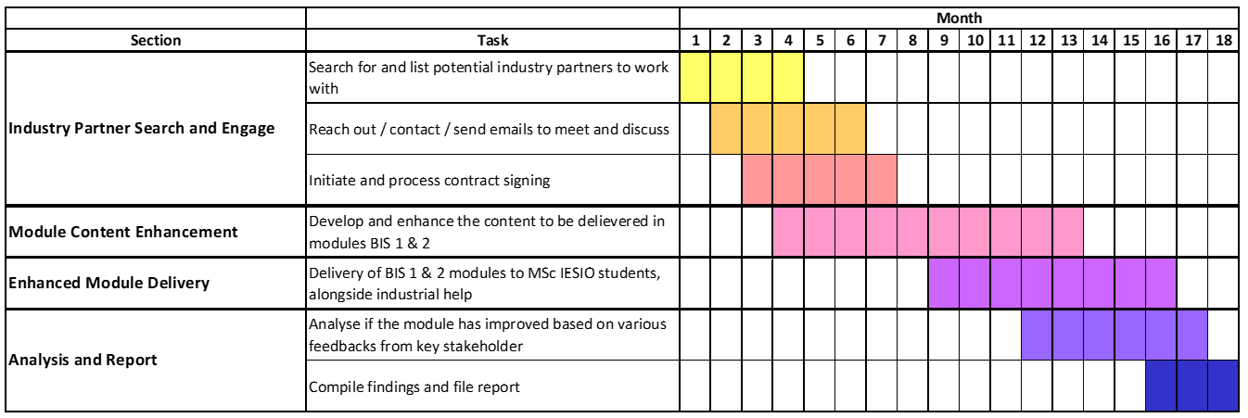

3. Expected Deliverables for Syntegrative Education and Dissemination for sharing (up to 200 words)
Please write how the University / academic community will know about the team’s outcomes and how you will ensure your dissemination of results is effective.

The enhanced Bespoke Industrial Studios will lead to significant improvements in both the modules and the overall MSc IESIO programme. Key deliverables include:
- A set of industrialized, problem-based learning, and case-studies-led, of teaching materials, for each Bespoke Industrial Studio module, which comprises of:
  - Enhanced Student Learning Experience: With updated content that reflects cutting-edge industrial practices and a greater emphasis on real-world problem-solving, students will gain a deeper understanding of the manufacturing, R&D, and supply chain sectors. This will directly lead to higher levels of student engagement and satisfaction, as the modules will be more aligned with their career goals and industry needs.
  - Stronger Industry Integration: By increasing the involvement of industry partners in problem-based learning with students, we will create a more immersive learning environment. This will allow students to work on real, current industrial problems, making learning experience more relevant and practical.
  - Improved Module Outcomes: The integration of new case studies into the module structure will ensure that students develop skills that are in demand by employers. This will enhance their employability and readiness to enter the workforce with the ability to tackle complex industrial challenges.
  - Continuous Improvement of the Programme: The materials will be updated to ensure that they remain relevant and valuable, contributing to the long-term success of the MSc IESIO programme​​​.

4. Budget (up to 200 words)
Please summarise the anticipated costs in the Table below and provide a justification for each specific budget sub-category.
Budget Items: (Please add items to the following categories as appropriate.)

No. | Budget Description | Justification | Budge Value (RMB)
1 | Industrial Fees for Companies | Charges incurred by the various industrial companies and firms for them to work with us to develop, enhance, and deliver the modules. | RMB 49000
2 | Travel costs | Travel expenses for members when travelling to companies for discussion and contract signing | RMB 1000
Total |  |  | RMB 50000

